**OCT MATLAB code documentation.**

Version 0.1

Created for Anton’s Medical Health Informatics 4th year thesis project at Western University (2021-2022)

Anton Hung

May 3, 2022

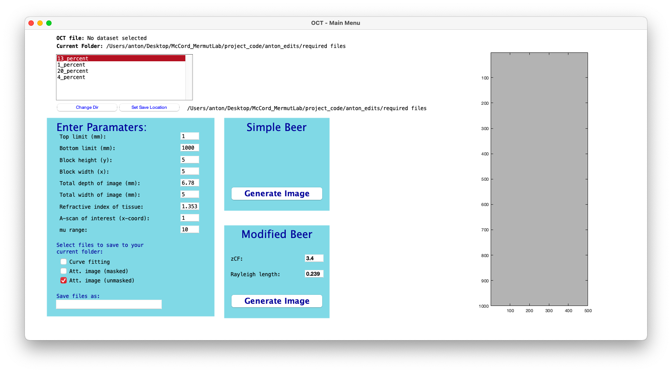

**Table of contents**

Part 1 – Deep dive into the scripts

1. octrun.m
2. setWorkSpace.m
3. readCSVdata.m
4. dispfig1.m
5. beerMatrix.m
6. attenuationImages.m
7. ginput_ac_grapher_full_onlysimpleBeer

Part 2 – Tutorial

1. How to organize your input datasets
2. Running octrun.m
3. Setting your current working directory
4. Specifying your custom parameters
5. Model selection / Image generation
6. Region selection for saving attenuation coefficients
7. Looking at the output

Known bugs

Part 1 - *Deep dive into the scripts*

# a. octrun.m

octrun is the main menu. It generates the user interface (GUI) for directory selection, dataset selection, parameter specification, and model specification. There is also a preview window to observe the selected pre-processed OCT image.

octrun can be executed either by typing octrun in the MATLAB command window or pressing the green play button in the MATLAB UI.

This function encompasses several uicontrol objects. These are objects that appear visually in the UI window and include a few types such as:

* Listbox: a box with filenames where you can scroll and multi-select files.
* Text: descriptive text printed in the UI. Found next to edit boxes.
* Edit: boxes that you can type in to change variables.
* Checkbox: boxes that you can select.
* PushButton: buttons that you can click on to execute an action

The type of the uicontrol object can be identified and changed by looking at the argument following “style”. All of these uicontrol objects, except “text”, have a “callback” argument. This means that when you execute an action on one of these uicontrol objects (click on, type a value, etc.), it will activate a certain function. All “callback” functions are found within the octrun.m script, rather than being found in external functions.

The very last line in the code is setWorkSpace(DS_LISTBOX, currDirectory);. This is needed to set the initial workspace upon opening the application. It runs the script setWorkSpace.m to fill the listbox with filenames, if omitted, the listbox would be empty.

## Uicontrol objects and callback functions

**OCTMENU**

This uses the built-in figure function to create the main “window” where all followinguicontrol objects will use as a “canvas” for printing text.

**@QUIT_CALLBACK**

This is activated when the x button is clicked to close the main menu. It will prompt the user to confirm whether they want to close all MATLAB figures, or just the main menu. Useful for when you’ve generated many figures and want to close them all at the same time.

**DS_LISTBOX**

This is the only listbox object I included. setWorkSpace.m loads the foldernames of folders in the current directory. Clicking on one more more foldernames will activate the callback function @DS_LISTBOX_CALLBACK

**@DS_LISTBOX_CALLBACK**

* This function is called whenever a new dataset in the Listbox is selected.
* The result of this is the cell array, I1.
* If file organization is in the form of nested directories with multiple .csv files inside every directory, then this function is producing a nested cell array in the form {{1_1.csv, 1_2.csv, 1_3.csv}, {2_1.csv, 2_2.csv, 2_3.csv},...{n_1.csv, n_2.csv, n_3.csv}}
* For every .csv file, we are storing the matrix of intensity data. In the above example, there are 3 intensity matrices per patient.
* Additional actions:
* Stores selected foldernames
* In the main menu, prints the filename of the last .csv in the selected datasets
* Runs dispfig1.m to plot a preview of the last .csv matrix in the selected datasets

**SET_WORKSPACE_BUTTON and @WORKSPACE_CALLBACK**

Creates a button labeled “Change Dir”. Can be clicked to change the users current working directory, where datasets will be loaded from.

**SET_SAVE_LOCATION_BUTTON and @SAVE_LOCATION_CALLBACK**

Creates a button labeled “Set Save Location”. Can be clicked to change the location on your computer where results will be saved.

**PARAMETERS_EDIT and @INPUTGLOPARAMS_CALLBACK**

Creates fillable edit boxes. Can customize the following parameters to suit your needs:

Top limit (mm):

Bottom limit (mm):

Block height (y):

Block width (x):

Total depth of image (mm):

Total width of image (mm):

Refractive index of tissue:

A-scan of interest (x-coord): *Has not been maintained/No longer used

mu range:

**CHECKBOXES and @SAVE_CHECKBOX_CALLBACK**

Creates checkboxes with the following labels:

Fitted curve *Has not been maintained/No longer used

Att. image (masked) *Has not been maintained/No longer used

Att. image (unmasked): By default, the only one selected

These three checkbox options were initially created to allow the user to save multiple types of images after running the program. Later on, there was no longer any benefit to saving fitted curves and masked images, and I did not continue to update the code for these two options while I made new adjustments to the rest of the script. By default, only the unmasked image is selected, and this is currently the only setting that works.

**edit_FILENAME and @FILENAME_CALLBACK**

Creates an edit box labeled “Save files as:”. Typing a foldername here will save your results in a folder with this name in the save location previously specified in SET_SAVE_LOCATION_BUTTON.

**SIMPLEBEER_BUTTON and @SIMPLEBEER_CALLBACK**

Creates a button labeled “Generate Image” in the Simple Beer window. Clicking this box will run other scripts (beerMatrix.m, attenuationImages.m) for calculating attenuation coefficients and generating attenuation maps according to the Simple Beer Law.

**edit_ZCF and @ZCF_CALLBACK**

Creates an edit box labeled “Confocal distance:”. Type in the confocal distance of your OCT system here, which will be used in subsequent Modified Beer calculations.

**edit_ZR and @ZR_CALLBACK**

Creates an edit box labeled “Rayleigh Length:”. Type in the Rayleigh length of your OCT system here, which will be used in subsequent Modified Beer calculations.

**MODIFIEDBEER_BUTTON and @MODIFIEDBEER_CALLBACK**

Creates a button labeled “Generate Image” in the Modified Beer window. Clicking this box will run other scripts (beerMatrix.m, attenuationImages.m) for calculating attenuation coefficients and generating attenuation maps according to the Modified Beer Law.

# b. setWorkSpace.m

This script is called when “change dir” is clicked in the main menu. It is used to update the listbox in the main menu to display all folders in your new directory when you change your current working directory.

This retrieves the names of the folders in your new directory and displays all of them in the listbox.

# c. readCSVdata.m

This script is called when folders are “clicked on” within the listbox. When you click on a patient’s folder, this script will read the csv files inside of the selected folder. It will retrieve the OCT data as a matrix, I0. In octrun.m, matrices from all selected csv files will be appended to a cell array, I1_cell. I1_cell is in the form in the form {{1_1.csv, 1_2.csv, 1_3.csv}, {2_1.csv, 2_2.csv, 2_3.csv},...{n_1.csv, n_2.csv, n_3.csv}}. This was explained prior in octrun.m under *@DS_LISTBOX_CALLBACK*

# d. dispfig1.m

This script is used to display the raw OCT data as an image. It uses the imshow() MATLAB function to take the OCT data matrix and visualize it as a heatmap (higher values are bright white, lower values are dark black).

I have used the functions xticklabels and yticklabels to convert the x and y axis labels to millimeters instead of pixels.

# e. beerMatrix.m

This script is activated when Generate image is clicked (either simple or modified beer). It takes a raw OCT matrix and computes a new matrix of attenuation coefficients (the attenuation map). The function tracks which button is clicked, and uses *if* statements to calculated attenuation coefficients

Depending on the blockwidth and blockheight values chosen by the user, NaN values will be appended to the width and height of the matrix such that the new width and height of the matrix become divisible by the blockwidth and blockheight.

Lines 39-56: This for loop is partitioning the original matrix into blocks using the specified blockwidth and blockheight. Within each block, the values are averaged across the x-direction and put into a new matrix, averagedI. If the original matrix had a width of w, averagedI has a width of w/blockwidth.

Lines 79-end:

* There are two for loops, one nested inside the other. The outer loop iterates through the columns of averagedI. The inner loop iterates through the rows of averagedI.
* A variable, row counter is keeping count of the row index. It increases by one for every iteration of the inner loop. When it reaches the same value as blockHeight, it calculates a line of best fit through the previous blockheight-1 values.
* polyfit(x,blockAvgVector,1)
  + polyfit is a built-in MATLAB function that calculates a curve of best fit through a paired x and y data.
  + x is a linear vector where the number of values is equal to the blockHeight. It spans from (1 multiplied by the length of a pixel) TO (blockHeight multiplied by the length of a pixel).
  + blockAvgVector is a vector (dimensions: blockheight x 1) containing the current value and the previous blockheight-1 values.
  + 1 indicates that we are applying a linear fit.

If Simple Beer was selected:

The slope of the line of best fit is divided by -40*log10(exp(1) and multiplied by 2. This is the final attenuation coefficient for that block.

If Modified Beer was selected:

The equation is different. The attenuation coefficient is equal to:

2*(slope + 20*log10(hz(i-blockHeight+1)/hz(i))) /(-40*log10(exp(1)))

Hz is a vector that was initiated in lines 74-77 using the following code:

*hz = zeros(1,numrow);*

*for i = 1:numrow*

*hz(i) = 1/(((i*pxlLength_mm - zcf)/zr)^2 + 1);*

# f. attenuationImages.m

This function is mainly responsible for two things: activating ginput_ac_grapher_full_onlysimpleBeer.m to generate attenuation maps and saving results to your specified save location.

ginput_ac_grapher_full_onlysimpleBeer.m is called on line 26. “*ginput_ac_grapher_full_onlysimpleBeer(whichModel,blockedI,I,pxlLength_mm,pxlWidth_mm,murange,path,blockWidth,blockHeight)”*

lines 92-95 save the attenuation map matrices to a folder called “matrices”. Matrices are saved as a .mat files named after the patient ID and csv filename, eg. P026_1.mat.

# g. ginput_ac_grapher_full_onlysimpleBeer

Lines 14-18: Display the raw OCT image.

Lines 21-42: Display the generated attenuation map as a blue-yellow heatmap.

Lines 63-94: Prompt user to select a region of interest, draw the region of interest with a red rectangle, and determine the average attenuation coefficient within the box. Ginput function is used to retrieve user input clicks. Patch function is used to draw rectangles using the user inputted coordinates.

Lines 101-105: This saves the results.csv files to a folder named results. These csv files contain attenuation coefficients, selected area coordinates, and selected area dimensions.

Lines 108-110: This saves the figures as png images. Red boxes indicating the selected areas are included.

Part 2 - *Tutorial*

Here I will outline the steps for how to go from raw OCT data to obtaining attenuation coefficients.

**Because the program is split up into multiple scripts and your working directory will probably change, the very first, *essential* step is to add all scripts to your MATLAB path.**

**This is done by typing “*pathtool*” into the MATLAB command window. Doing so will open up the following window:**

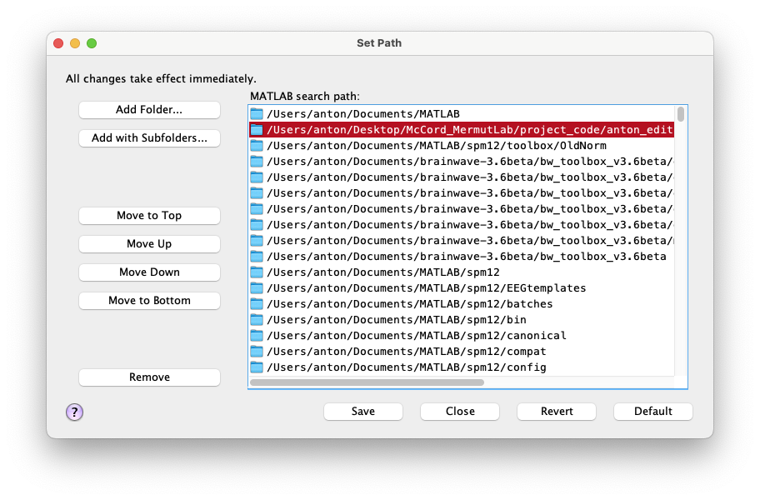

**Here, you must click on “Add with Subfolders…”, which will open up a file selection dialog box. Navigate to the folder with all the required scripts (**octrun.m, setWorkSpace.m, readCSVdata.m, dispfig1.m, beerMatrix.m, attenuationImages.m, ginput_ac_grapher_full_onlysimpleBeer**).**

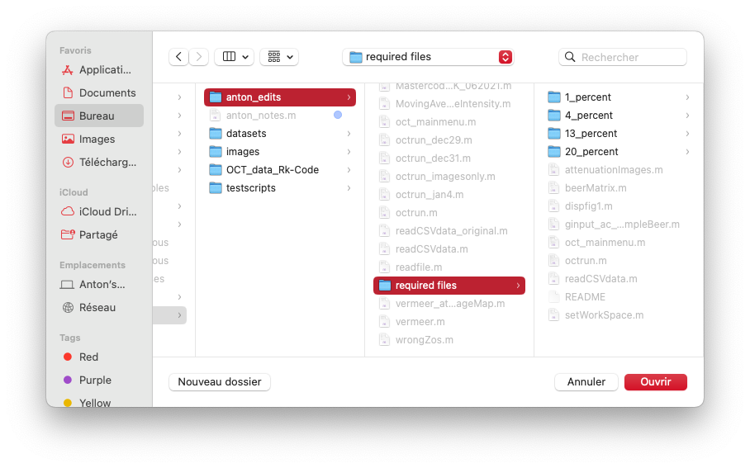



**Click “Open”, then “Save”. Now the scripts have been added to your MATLAB path and you can proceed.**

# a. How to organize your input datasets

Your datasets must be organized like so:

* Datasets are in the .csv format
* Every patient has their own subfolder, containing their .csv files in the folder

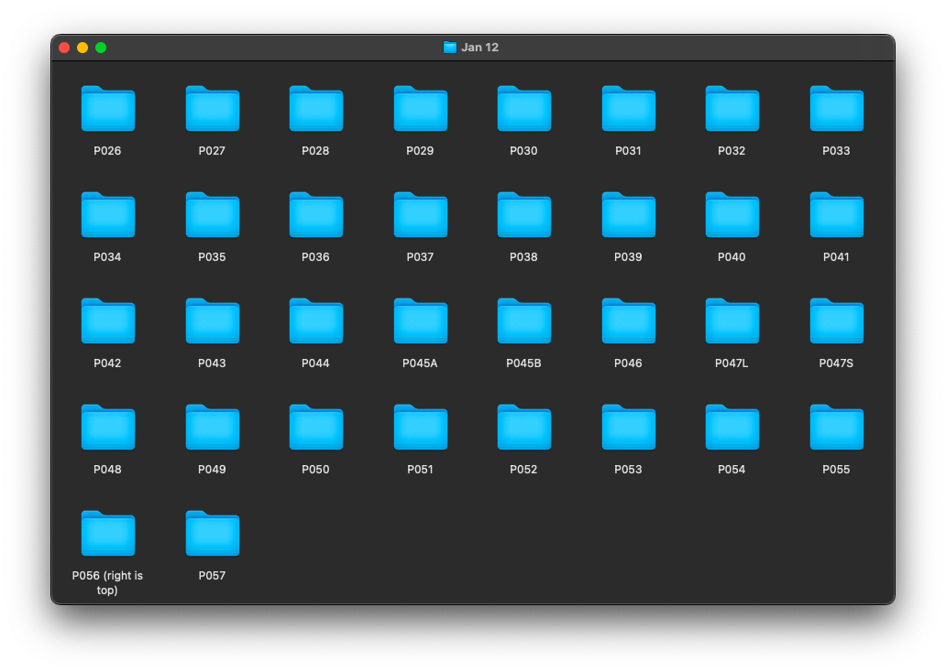

In the image above, there is a folder for every patient (#26 to #57).

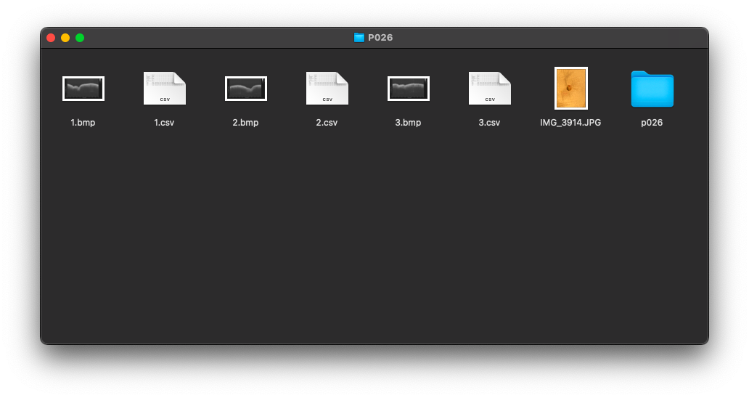

In the above image, I have clicked into the patient folder “P026”. Inside this folder, the files of interest are the three csv files “1.csv”, “2.csv”, and “3.csv”.

# b. Running octrun.m

Type *octrun* in the MATLAB command window or press the green play button with the octrun.m script open to generate the window below.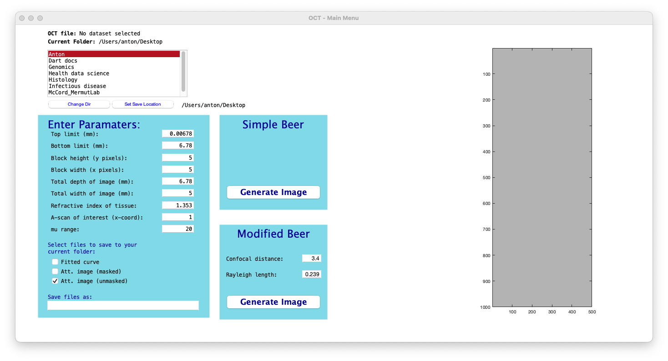

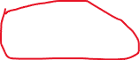

# c. Setting your current working directory

Starting with the top left, it shows that the folder that I am currently in is my desktop. My oct files are found in a directory under the path “/Volumes/Seagate Portable Drive/Santec Western Data/Jan 12”.

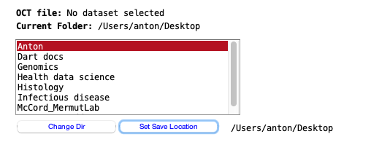

I need to set my current working directory to the directory containing my OCT files. This is done by clicking Change Dir and navigating to the desired folder.

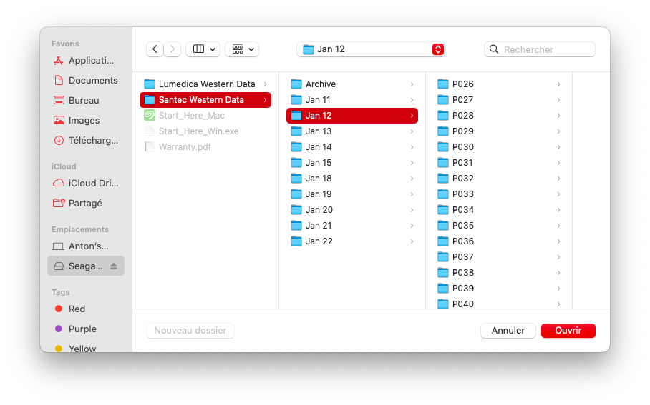

Click on the directory containing all your folders of OCT data (in this example, “Jan 12”), and click “open” (Do not click into any of the patient subfolders yet. Eg. “P026, P027, etc.”)

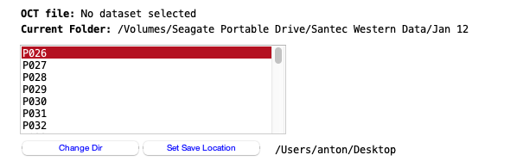

Now all the patient subfolders will be visible in the listbox. The next two steps that can be done here are: Setting the location where results will be saved, and selecting which patients will include in the analysis.

Setting the save location works exactly like setting the current working directory. I will keep mine as the desktop for this demonstration.

Selecting datasets can be done a few ways.

1. You can decide to only select one patient.
2. The usual hotkeys for multi-selecting files can be used.
   1. Shift + arrow keys can be used to select multiple consecutive folders
   2. Cmd + a (mac) OR ctrl + a (windows) can be used to select all folders
3. The method I used in my project and will follow in this demonstration is selecting a specific subset of the folders using cmd + click (mac) OR ctrl + click (windows)

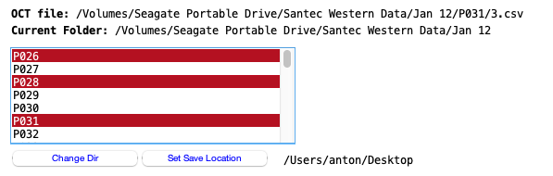

Here, you can see that I have selected three patients: P026, P028, and P031. At the top, “OCT file:” now reads the path to the last .csv file in the last selected folder (in this case, P031/3.csv, which is the third csv file found in the P031 folder).

Additionally, a preview of P031/3.csv is now visible in the main menu (on the right side of the window).

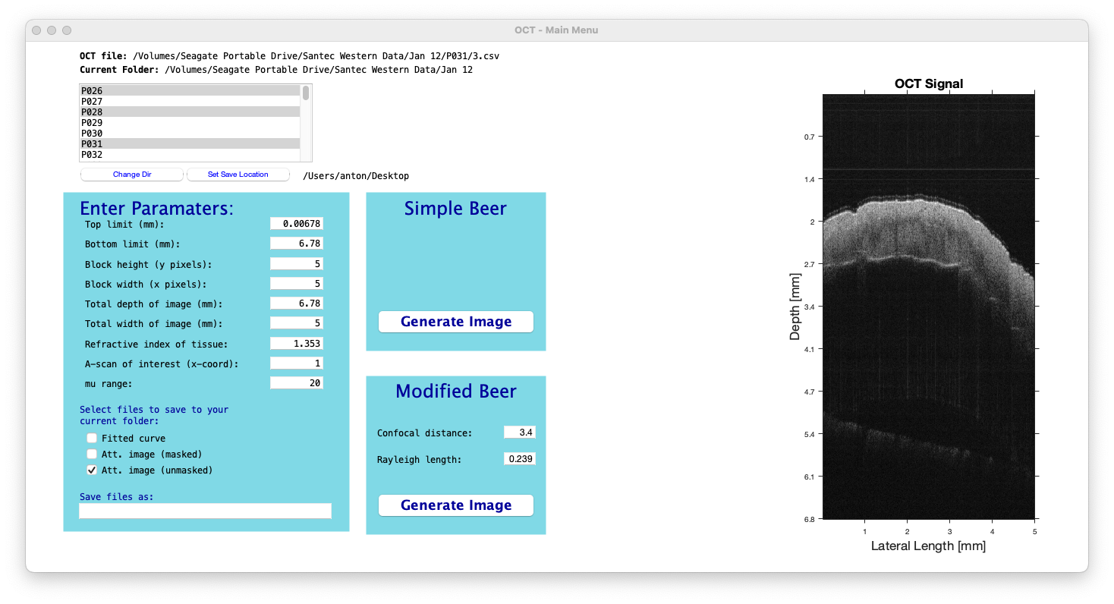

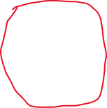

# d. Setting analysis parameters

We now have our datasets selected and our save location set. The next step is to specify our analysis parameters. All options are, by default, set to the values that I used in my project. The options are:

1. Top limit (mm): *Default = top of image.* This option sets an upper boundary for the OCT image, where all pixels above the horizontal line (where y = top limit) are set to 0.
2. Bottom limit (mm): *Default = bottom of image.* This option sets a lower boundary for the OCT image, where all pixels below the horizontal line (where y = bottom limit) are set to 0.
3. Block height (y pixels): *Default = 5.* This determines the block height used for fitting and averaging. In units of pixels, rather than mm.
4. Block width (x pixels): *Default = 5.* This determines the block width used for fitting and averaging. In units of pixels, rather than mm.
5. Total depth of image (mm): *Default = 6.78.* The maximum y-value of the OCT image in mm.
6. Total width of image (mm): *Default = 5.00.* The maximum x-value of the OCT image in mm.
7. Refractive index of tissue: *Default = 1.353.* You can choose an appropriate refractive index for your tissue.
8. A-scan of interest (x-coord): *\*\*\* This currently does not serve any purpose and has no effect. It was first implemented with the intention of allowing the user to select a single vertical column in the image for drawing an intensity-decay curve of that vertical vector. However, it didn’t fulfill any of my needs, so I did not continue to work on it.*
9. Mu range: *Default = 20.* When the attenuation image is created, this sets the maximum value for the range of values in the colourbar.

Save options:

Select files to save to your current folder:

* This was designed with the intent of allowing the user to save different kinds of images in their results, depending on their needs.
* **Currently, only att. Image (unmasked) serves any purpose, and the others are not working as they have not been updated along with the rest of the script. “Unmasked” is the only one that is selected by default, and is the only option that will be explored in this demonstration. It generates a figure with the raw OCT image and generated attenuation map side-by-side.**
* Att. Image (masked) served a purpose in the beginning when I was working on uniform intralipid data. It used the top limit and bottom limit options above to zero parts of the image. This made the images look nicer aesthetically.
* Fitted curve used to add the option of saving intensity-decay curves for intralipid data.



*This is an intensity-decay curve of two different concentrations of intralipid data created using the “fitted curve” option at the very beginning of my project. Generating these images is probably not possible with this current version of the code, as it has not been updated along with the rest of my changes.*

Finally, a filename can be set under “Save files as:”. I will use the name “demo”

To recap, all the options I used were left as their default values, except that I chose a save filename for my output results.



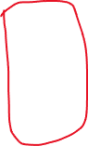

# e. Model selection

Now that datasets are selected and parameters are set, we can choose which model will be used for computing attenuation coefficients. I will use the Simple Beer model (see MATLAB script “beerMatrix.m” to observe the differences in computation between simple and modified beer). Click on “Generate Image” to proceed with the analysis.

# f. Region selection for saving attenuation coefficients

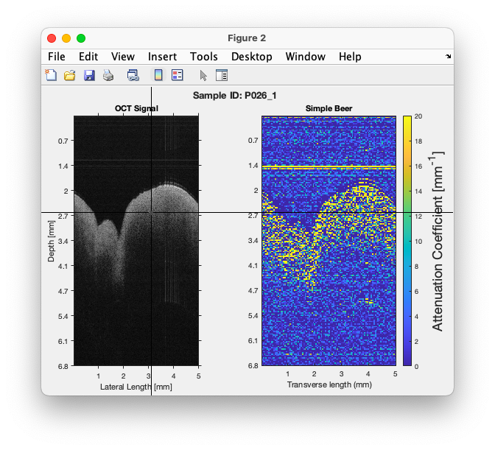

A figure will appear containing the raw OCT signal (left) and attenuation map (right). The above figure corresponds with the OCT dataset: *P026/1.csv.* The program will iterate through and generate figures for all the csv files in the selected folders from part c.

The figure also has cross-hairs that follow your cursor. You can use the cross-hairs to select two corners, which will be used to draw a rectangle for region selection within the image.

The two dots must be selected from the OCT signal (black and white image). The UI will permit you to click on the attenuation map (blue/green/yellow image), but doing so will cause unexpected problems.

Accidentally clicking outside of the image axes will cause an error. Simply close the figure and click on *Generate image* from *step e* again.

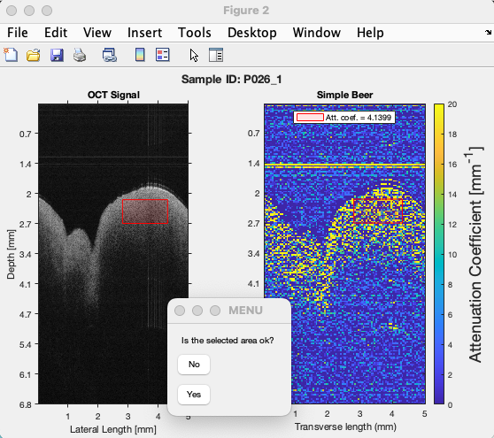

After selecting two points in the OCT signal, a red rectangle will be drawn in both images. And in the OCT image, there will be some text printed to indicate the average attenuation coefficient in the selected area.

You will be prompted to confirm whether you are satisfied with the area you have selected. If you click “No”, nothing is saved and you may select a new area. If you click “Yes”, then some results will be saved (expanded on later), and the next image in the selected dataset will be loaded. Remember, I am running the simple beer model on 3 patients (P026, P028, P031). Each patient has 3 .csv files each. Therefore, the program will generate 9 figures one-after-the-other and ask me to repeat this process of selecting regions.

After selecting regions for all 9 images, you will observe that there is a folder in your desktop (save location chosen in *step c*) with a folder called “demo” (save name chosen in *step c* as well).

# g. Looking at the output

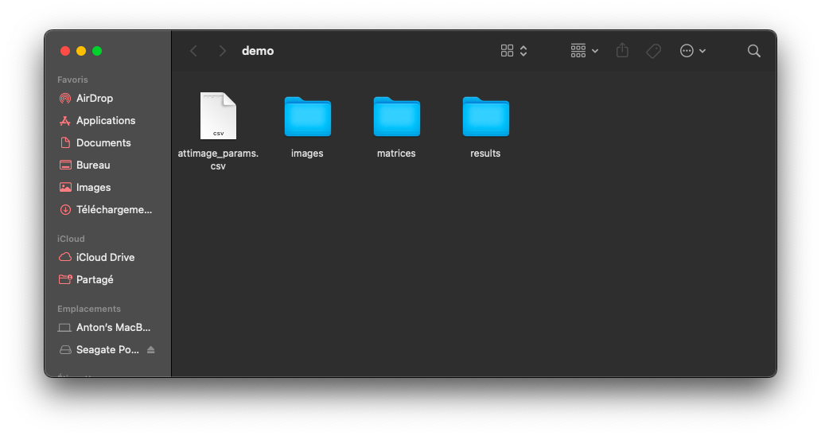

The folder “demo” contains the aggregated results for all 9 OCT images.

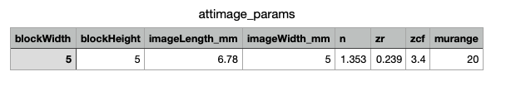Attimage_params.csv contains the parameters used in your analysis. All modifiable variables are saved here. Remember, top limit, bottom limit, and A-scan of interest currently do not provide anything to the analysis, so I did not code for them be included in the saved parameters. Zr and zcf only play a role if he modified beer model is chosen but they are nonetheless included in the attimage_params file if the simple beer model is used.

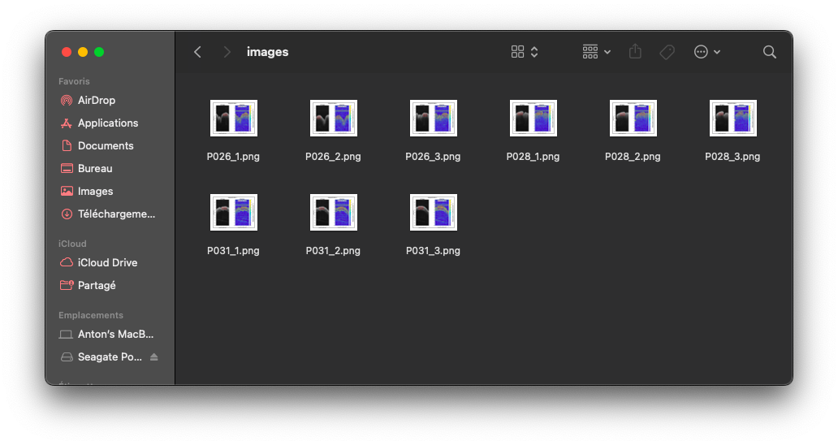

The ”images” folder contains the figures (pairs of OCT signals/attenuation images). The attenuation images can be accessed again to observe selected regions and their attenuation coefficients.

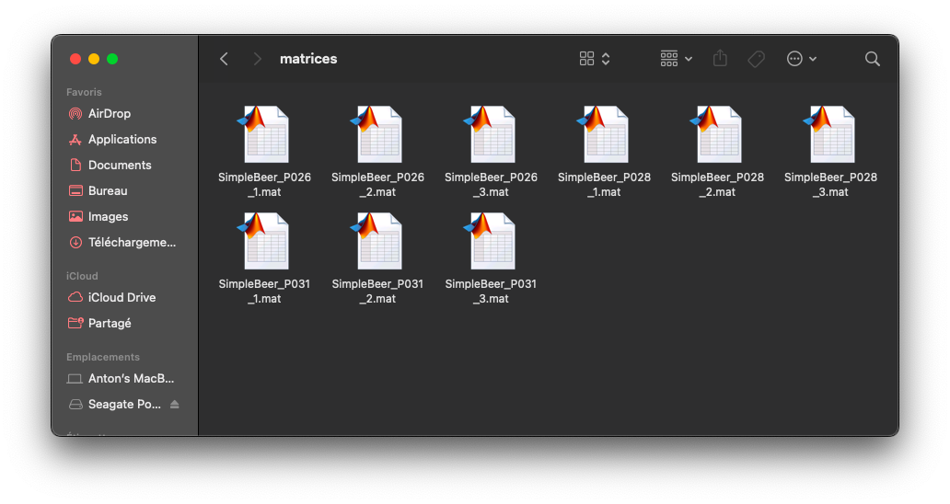

The “matrices” folder contains .mat files. These contain the matrix data for all attenuation images. Important: these are not your raw OCT signals. Rather, they are the post-processed/computed attenuation coefficient maps in matrix form. These may be useful if you want to take the region selection coordinates from a different analysis and apply the exact dimensions to your new matrices.

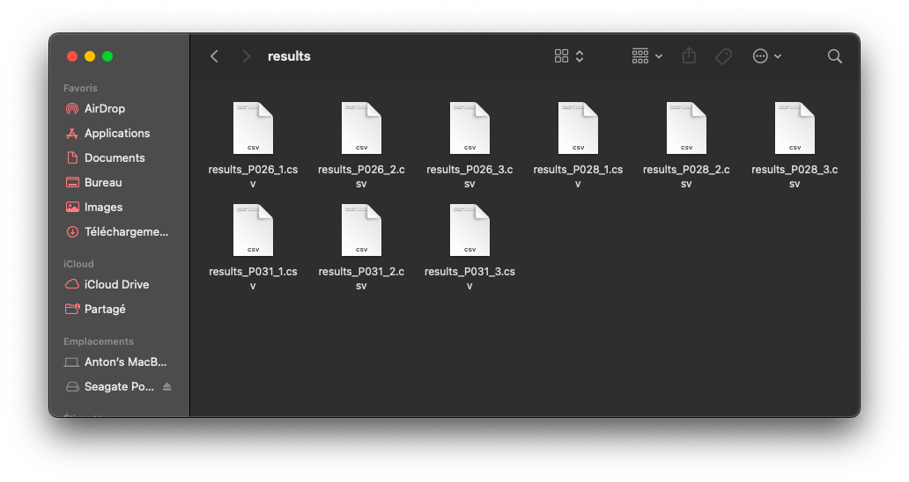

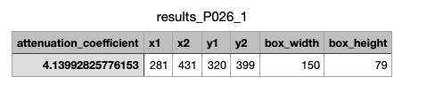

The “results” folder contains a .csv file for every saved image. These .csv files are a single row of data (they can all be appended to the same table using software. For example, rbind in the programming language R). The average attenuation coefficient in the selected region is saved, along with the coordinates of the selected box, and the box dimensions.

Known bugs

1. Disappearing listbox for selecting datasets

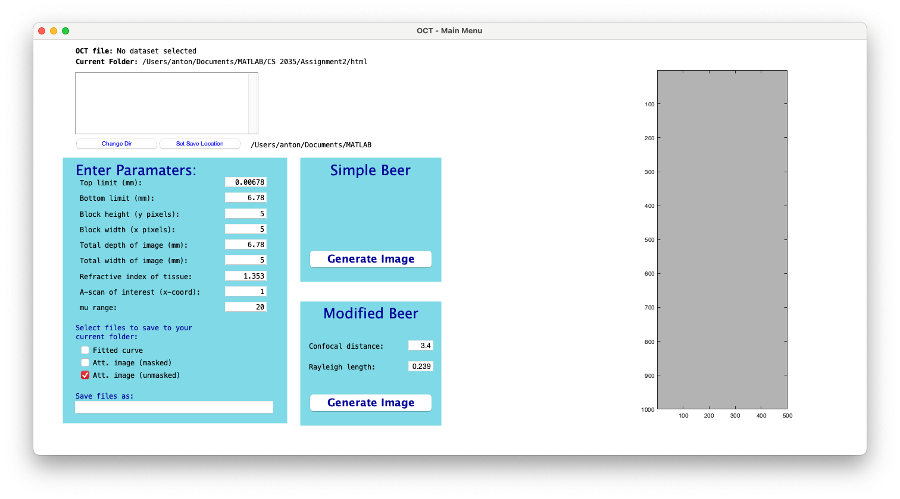

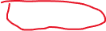

Once in a while, I observed a bug when trying to use the “Change Dir” button. For unknown reasons, very rarely, the listbox will disappear (become entirely blank) after clicking the following sequence of steps:

* Clicking “Change Dir”
* Choosing your directory and clicking “open”

When this occurs, datasets cannot be loaded and they only solution is to close the window and reopen it. If this happens, be careful to re-enter any analysis parameters that you changed.

*The end.*